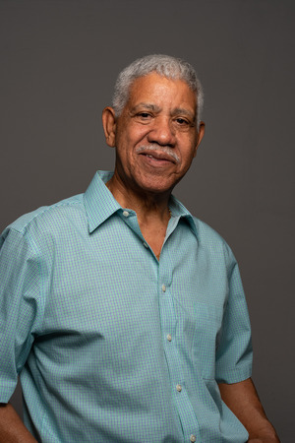

He retired as a computer engineer from a PSU. He is a tech savvy and uses many IoT devices for daily use. He is interested in writing blogs. He loves to drive his car. Mr. Arun Kumar suffers from amnesia and usually forgets where he has put his belongings.

* STATUS: Married
* LOCATION: Delhi

**NEEDS**

1. Tends to forget where he had kept his car keys.
2. Forgets about charging his fitness tracker and realizes that on morning walks.
3. Once he had forgotten iPod at a restaurant.
4. He wants to use all his devices carefully without losing them.
5. He does not want to be late for his morning walk and hence wants to be informed about his Fitbit battery and where it is kept.

**ABOUT**

 AGE: 66

* EDUCATION: Graduate
* OCCUPATION: Retired Government Employee

**ABOUT ARUN KUMAR**

**GOALS**

**FRUSTRATIONS**

**ARUN KUMAR**

**EXPECTATIONS**

­­­­­­

“I tend to forget where I have kept my utilities but now, I have been able to keep track of them using this mobile app"

1. To have a versatile IoT device manager.
2. Wants to know real-time battery status of all his devices.
3. Needs a convenient tracker for his devices.
4. The device manager should manage devices efficiently.
5. Should be able to control all his devices remotely.
6. The software should be easy to use and understand.